**Assignment 2**

**Name – SURAJ KUMAR YADAV**

**ROLL NO. – 20220PHY014**

1. **Half Adder**
   1. Sum of 1 and 1

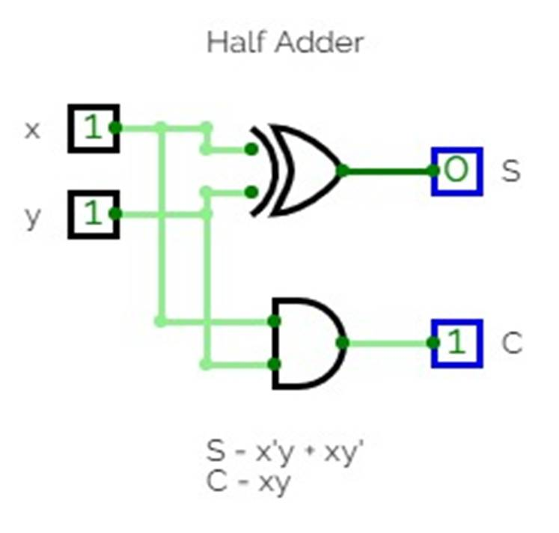

* 1. Sum of 1 and 0

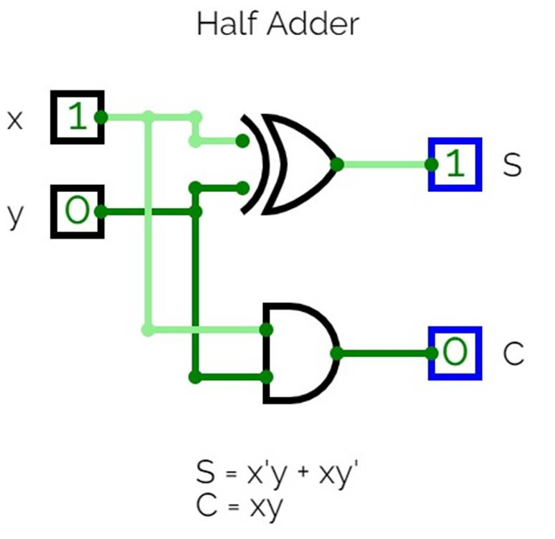

1. **Full Adder**
   1. Sum of 1, 1 & 1 🡪 1 + 1 + 1

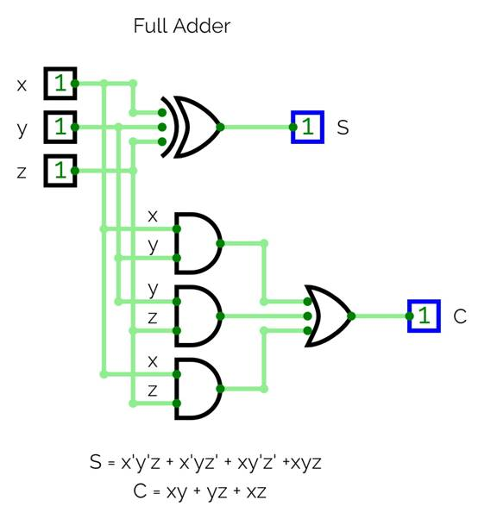

* 1. Sum of 1, 1 & 0

